Astwood Bank Primary School Choir!
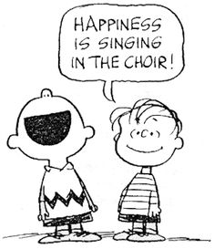
Dear Parents/Carers,
Your child has expressed an interest in joining the school choir. This term we are having a choir from just year 3 and year 4 with the aim of attending the Young Voices concert in Birmingham on 10th January 2022. Rehearsals will be Monday lunchtimes but will also require additional times.

We have limited places for the Young Voices concert so we may need to draw names from a hat if we’re over-subscribed. Once this is settled, the concert letter itself will then be sent home. This letter is already on the choir page of the website so you can see the details of the concert and what the costs and commitment will be. Please do look at this before deciding if you’d like your child to be in the choir.

We will also need a couple of DBS helpers to come with us to the concert so do let me know if you’re interested. These adults will then not need an audience ticket themselves.

We will be taking video of our performances throughout the year which may be uploaded onto YouTube. The school website itself is not ideal for hosting video and we’d like to be able to share these with you from time to time. We take online safety very seriously; no child will be named in our videos and links will be posted on the choir page. As a school we can’t guarantee how this material will be used once it is in the public domain. If you have any questions or concerns about this please do ask.

We intend to have lots of fun with choir but do regard it as a serious commitment so please do reinforce this with your children. Our choir members are often seen performing in public places and are always excellent ambassadors for the school. Remember, the first port of call for information is always the choir page on the school website. [ABPS website/ school community/ making music/ choir]

Mr George (choir director)

Return to your child’s class teacher by Thursday 9th September 2021

Child’s Name: Class:

My child would like to join the school choir and I am happy for video footage and photographs to be taken at concerts and events. I am also happy for photos and video featuring my child to appear online, such as YouTube, and also in local newspapers. I will inform school if this situation changes.

Please also tick if you have a current DBS form and would like to help at Young Voices.

Signed:

